Big Data-Climate Change

1. **Problem one—Creating Your First Model**
2. Implement a function closed_form_1 that computes this closed form solution given the features X, labels Y(using Python or Matlab)

import numpy as np

import pandas as pd

import matplotlib.pyplot as plt

from mpl_toolkits.mplot3d import Axes3D

import statsmodels.api as sm

df = pd.read_csv('climate_change_1.csv')

def closed_form_1():

traindata = df[df.Year<=2006]

testdata = df[df.Year>2006]

X = traindata[['MEI','CO2','CH4','N2O','CFC-11','CFC-12','TSI','Aerosols']]

Y = traindata['Temp']

est = sm.OLS(Y, sm.add_constant(X)).fit()

print(est.summary())

print(est.params)

closed_form_1()

1. Write down the mathematical formula for the linear model and evaluate the model $R^{2}$ on the training set and the testing set.

$$y=-124.594260+0.064205×MEI+0.006457×CO2+0.000124×CH4-0.016528×N2O-0.006630×CFC-11+0.003808×CFC-12+0.093141×TSI-1.537613×Aerosols$$

The $R^{2}$ on training set is 0.744

The $R^{2}$ on testing set is 0.425

1. Which variables are significant in the model?

If the p-value is below 0.05, we will choose MEI, CO2, CFC-11, CFC-12, TSI, Aerosols.

1. Write down the necessary conditions for using the closed form solution. And you can apply it to the dataset climate_change_2.csv, explain the solution is unreasonable.

Necessary conditions: MEI, CO2, CH4, N2O, CFC-11, CFC-12, TSI, Aerosols should not be correlated with each other.

Unreasonable: N2O and CFC-11 are greenhouse gases and the regression coefficients of them should be positive but the results are negative. Therefore, N2O and CFC-11 are correlated with other variables in the data set.

1. **Problem two—Regularization**

**Regularization is a method to boost robustness of model, including $L_{1}$ regularization and $L_{2}$ regularization.**

1. **Please write down the loss function for linear model with $L_{1}$ regularization and $L_{2}$ regularization, respectively.**

$L_{1}$ Regularization: $$C=C_{0}+\frac{λ}{n}\sum_{ω}{\left|ω\right|}$$

$L_{2}$ Regularization: $$C=C_{0}+\frac{λ}{2n}\sum_{ω}{ω^{2}}$$

$C_{0}$ represents the original cost function.

1. **The closed form solution for linear model with $L_{2}$ regularization.**

import numpy as np

import pandas as pd

import matplotlib.pyplot as plt

from mpl_toolkits.mplot3d import Axes3D

import statsmodels.api as sm

df = pd.read_csv('climate_change_1.csv')

def closed_form_2():

lamb = 0.5

df['const'] = 1

traindata = df[df.Year<=2006]

testdata = df[df.Year>2006]

X = traindata[['MEI','CO2','CH4','N2O','CFC-11','CFC-12','TSI','Aerosols','const']]

Y = traindata['Temp']

Theta2 = np.dot(

np.dot(np.linalg.inv((np.dot(X.T, X) + lamb * np.eye(X.shape[1]))), X.T), Y)

print(Theta2)

closed_form_2()

**Result:**

|  |  |
| --- | --- |
| Item | $$θ$$ |
| MEI | 4.55768014e-02 |
| CO2 | 7.80443532e-03 |
| CH4 | 1.95701031e-04 |
| N2O | -1.64893727e-02 |
| CFC-11 | -6.38359095e-03 |
| CFC-12 | 3.74766007e-03 |
| TSI | 1.44919104e-03 |
| Aerosols | -3.65599605e-01 |
| Const | -4.68953239e-03 |

1. **Compare the two solutions in problem 1 and problem 2 and explain the reason why linear model with $L_{2}$ regularization is robust.**

The reason why the $L_{2}$ method is better than before is that the size of the coefficient of the constant term of the $L_{2}$ method is basically the same as the value of the temp result, which will not cause a large deviation of the result due to the error of the constant term estimation.

1. **You can change the regularization parameter λ to get different solutions for this problem.**

|  |  |  |
| --- | --- | --- |
| $$λ$$ | $R^{2}$**of Training Set** | $R^{2}$**of Testing Set** |
| **10** | **0.6746079231515448** | **0.9408716921954439** |
| **1** | **0.6794692110104662** | **0.8467501178134881** |
| **0.1** | **0.6944684109361836** | **0.6732879125422909** |
| **0.01** | **0.7116529617244923** | **0.5852763146622774** |
| **0.001** | **0.7148330433597858** | **0.5625217958135218** |

**Code:**

import numpy as np

import pandas as pd

import matplotlib.pyplot as plt

from mpl_toolkits.mplot3d import Axes3D

import statsmodels.api as sm

df = pd.read_csv('climate_change_1.csv')

def R_square(Y_pred, Y):

ESS = np.sum((Y_pred - Y.mean())**2)

TSS = np.sum((Y - Y.mean())**2)

R2 = ESS / TSS

print(R2)

def closed_form_2():

lamb = 0.001

df['const'] = 1

traindata = df[df.Year<=2006]

testdata = df[df.Year>2006]

X = traindata[['MEI','CO2','CH4','N2O','CFC-11','CFC-12','TSI','Aerosols','const']]

Y = traindata['Temp']

Theta2 = np.dot(

np.dot(np.linalg.inv((np.dot(X.T, X) + lamb * np.eye(X.shape[1]))), X.T), Y)

print(Theta2)

Y_pred = np.dot(X,Theta2)

R_square(Y_pred,Y)

closed_form_2()

1. **Problem three—Feature Selection**
2. **From Problem 1， you can know which variables are significant, therefore you can use less variables to train model. For example, remove highly correlated and redundant features. You can propose a workflow to select feature.**

**Code:**

import numpy as np

import pandas as pd

import matplotlib.pyplot as plt

from mpl_toolkits.mplot3d import Axes3D

import statsmodels.api as sm

df = pd.read_csv('climate_change_1.csv')

climate_change_1_train = df[df.Year<=2006]

climate_change_1_test = df[df.Year>2006]

climate_change_1_train_X = climate_change_1_train.iloc[:,2:10]

climate_change_1_train_Y = climate_change_1_train.iloc[:,10]

print(climate_change_1_train_X.corr())

#80% above is considered as highly related

#CO2 CH4 N2O CFC-12 are highly correlated with each other

#CFC-11 CFC-12 are correlated with each other

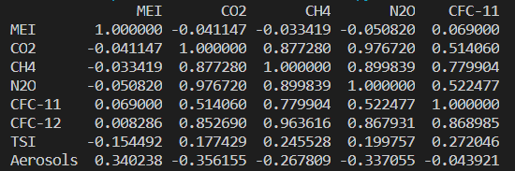

#delete N2O,CH4,CFC-12

climate_change_1_train_X_new = climate_change_1_train.loc[:,['MEI','CO2','CFC-11','TSI','Aerosols']]

# 1.2 run a regression remove not significant with alpha = 0.01

import statsmodels.api as sm

from statsmodels import regression

climate_change_1_train_X_new=sm.add_constant(climate_change_1_train_X_new)

model=sm.OLS(climate_change_1_train_Y,climate_change_1_train_X_new)

res=model.fit()

print(res.summary())

#delete CFC-11 which is not significant

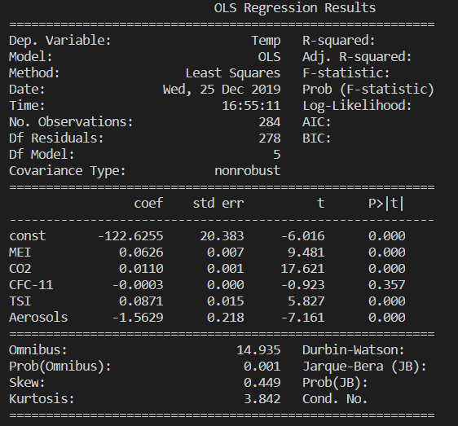

# 1.3 run the final model

climate_change_1_train_X_new_2 = climate_change_1_train.loc[:,['MEI','CO2','TSI','Aerosols']]

climate_change_1_train_X_new_2=sm.add_constant(climate_change_1_train_X_new_2)

model=sm.OLS(climate_change_1_train_Y,climate_change_1_train_X_new_2)

res=model.fit()

print(res.summary())

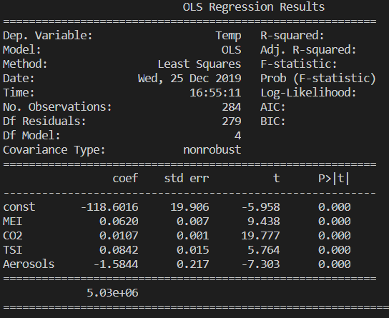

Result:

We will use MEI, CO2, TSI and Aerosols.

1. **Train a better model than the model in Problem 2.**

**Code:**

import numpy as np

import pandas as pd

import matplotlib.pyplot as plt

from mpl_toolkits.mplot3d import Axes3D

import statsmodels.api as sm

df = pd.read_csv('climate_change_1.csv')

def R_square(Y_pred, Y):

ESS = np.sum((Y_pred - Y.mean())**2)

TSS = np.sum((Y - Y.mean())**2)

R2 = ESS / TSS

print(R2)

def closed_form_2():

lamb = 0.1

df['const'] = 1

traindata = df[df.Year<=2006]

testdata = df[df.Year>2006]

X = traindata[['MEI','CO2','TSI','Aerosols',’const’]]

Y = traindata['Temp']

Theta2 = np.dot(

np.dot(np.linalg.inv((np.dot(X.T, X) + lamb * np.eye(X.shape[1]))), X.T), Y)

print(Theta2)

Y_pred = np.dot(X,Theta2)

R_square(Y_pred,Y)

closed_form_2()

1. **Problem Four-Gradient Descent**

**Iterative Expression:**

$$θ_{j}≔θ_{j}-α\frac{1}{m}\sum_{i=1}^{m}{(h_{θ}(x^{\left(i\right)})-y^{(i)})x_{j}^{(i)}}$$

**Code:**

import numpy as np

import pandas as pd

import matplotlib.pyplot as plt

from mpl_toolkits.mplot3d import Axes3D

import statsmodels.api as sm

from sklearn.preprocessing import normalize

df = pd.read_csv('climate_change_1.csv')

def Gradient_Descent(alpha, theta_0, x, y, tol):

theta = theta_0

cost = (1./(2*len(x))) * (np.sum((x @ theta_0 - y)**2))

count = 0

while not ((cost <= tol) | (count > 10000)):

count += 1

theta = theta - alpha * (1./len(x)) * (x.T @ (x @ theta - y))

cost = (1./(2*len(x))) * (np.sum((x @ theta_0 - y)**2))

print(theta)

print('迭代共{}次'.format(count))

print(theta)

def regularit(df):

newDataFrame = pd.DataFrame(index=df.index)

columns = df.columns.tolist()

for c in columns:

if c != 'const':

d = df[c]

MAX = d.max()

MIN = d.min()

newDataFrame[c] = ((d - MIN) / (MAX - MIN)).tolist()

else:

newDataFrame[c] = 1

return newDataFrame

def closed_form_2():

lamb = 0.1

df['const'] = 1

traindata = df[df.Year<=2006]

testdata = df[df.Year>2006]

X = traindata[['MEI','CO2','CH4','N2O','CFC-11','CFC-12','TSI','Aerosols','const']]

Y = traindata['Temp']

X = regularit(X)

Y = (Y-Y.mean())/(Y.max()-Y.min())

print(X)

print(Y)

Theta2 = [1,1,1,1,1,1,1,1,1]

Gradient_Descent(0.001, Theta2, X, Y, 10)

closed_form_2()